**Design and Development of an Online Shopping Management System**

by

**Maliha Akter Farjana**

ID: CSE2103024056

Supervised by

**Bulbul Ahamed**

Submitted in partial fulfillment of the requirements for the degree of Bachelor of Science in Computer Science and Engineering



**DEPARTMENT OF COMPUTER SCIENCE AND ENGINEERING**

**SONARGAON UNIVERSITY (SU)**

February 2020

**APPROVAL**

The project titled **“Online Shopping Management System”** submitted by **Maliha Akter Farjana (CSE2103024056)** to the Department of Computer Science and Engineering, Sonargaon University (SU), has been accepted as satisfactory for the partial fulfillment of the requirements for the degree of Bachelor of Science in Computer Science and Engineering and approved as to its style and contents.

**Board of Examiners**

a

|  |  |
| --- | --- |
| ----------------------------------------  **Bulbul Ahamed**  Associate Professor and Head,  Department of Computer Science and Engineering  Sonargaon University (SU) | **Supervisor** |
| ----------------------------------------  (Examiner Name and Signature)  Department of Computer Science and Engineering  Sonargaon University (SU) | **Examiner 1** |
| ----------------------------------------  (Examiner Name and Signature)  Department of Computer Science and Engineering  Sonargaon University (SU) | **Examiner 2** |
| ----------------------------------------  (Examiner Name and Signature)  Department of Computer Science and Engineering  Sonargaon University (SU) | **Examiner 3** |

**DECLARATION**

We, hereby, declare that the work presented in this report is the outcome of the investigation performed by us under the supervision of **Bulbul Ahamed, Associate Professor** and **Head,** Department of Computer Science and Engineering, Sonargaon University, Dhaka, Bangladesh. We reaffirm that no part of this Project has been or is being submitted elsewhere for the award of any degree or diploma.

|  |  |
| --- | --- |
| Countersigned  ------------------------------  **(Bulbul Ahamed)**  **Supervisor** | Signature  ------------------------  Maliha Akter Farjana  ID: CSE1502005023 |

**ABSTRACT**

**Online Shopping Management System** is the process of doing business through computer networks, where a person sitting in front of a computer can access all the facilities of the Internet to buy or sell products. Unlike traditional commerce, which requires physical effort to go and get products, e-commerce has made it easier for people to reduce physical work and save time. Online shopping which started in the early 1990s has taken a great leap in the world of computers; however, the major factor hindering its growth is security. Security remains the primary challenge facing online commerce today, and significant advancements are still being made in this field. The main advantage of e-commerce over traditional commerce is that users can browse online shops, compare prices, and order merchandise from home using their PC.To increase the use of online shopping in developing countries, B2B e-commerce is implemented to improve access to global markets in the field of commerce. However advancements in e-commerce are essential for the growth of developing countries. Research strategies highlight the importance of e-commerce in developing countries for business applications. Electronic commerce or e-commerce refers to any type of business or commercial transaction that involves the transfer of information across the Internet. It covers a wide range of businesses, from consumer-based retail sites to auction or music platforms, as well as business exchanges trading goods and services between corporations. It is currently one of the most important aspects of the Internet to emerge.

# ACKNOWLEDGMENT

At the very beginning, we would like to express my deepest gratitude to the Almighty Allah for giving us the ability and the strength to finish the task successfully within the schedule time.

We are auspicious that we had the kind association as well as supervision of **Bulbul Ahamed**, Associate Professor and Head, Department of Computer Science and Engineering, Sonargaon University whose hearted and valuable support with best concern and direction acted as necessary recourse to carry out our project.

We are also thankful to all our teachers during our whole education, for exposing us to the beauty of learning.

Finally, our deepest gratitude and love to my parents for their support, encouragement, and endless love.

**LIST OF ABBREVIATIONS**

|  |  |
| --- | --- |
| API | Application Programming Interface |
| ASP | Active Server Pages |
| CRUD | Create, Read, Update, Delete |
| CSS | Cascading Style Sheets |
| DBMS | Database Management System |
| EF | Entity Framework |
| HTML | HyperText Markup Language |
| HTTP | HyperText Transfer Protocol |
| HTTPS | HyperText Transfer Protocol Secure |
| IIS | Internet Information Services |
| JS | JavaScript |
| JSON | JavaScript Object Notation |
| MVC | Model View Controller |
| OOP | Object-Oriented Programming |
| SQL | Structured Query Language |
| UI | User Interface |

**TABLE OF CONTENTS**

|  |  |  |  |  |  |  |  |  |
| --- | --- | --- | --- | --- | --- | --- | --- | --- |
| Title | | | | | | |  | Page No. |
|  | | | | | | | | |
| **DECLARATION** ………………………………………………………….... | | | | | | | | iii |
| **ABSTRACT** ……………………...…………………………………………. | | | | | | | | iv |
| **ACKNOWLEDGEMENT** ………………………………………….……… | | | | | | | | v |
| **LIST OF ABBREVIATION** ………….……………………………………. | | | | | | | | vi |
|  | | | | | | | | |
| **CHAPTER 1** | | | | | | |  | 1 – 2 |
| INTRODUCTION TO ONLINE SHOPPING SYSTEM | | | | | | | |  |
|  | | 1.1 | | | Introduction ……..……………………………………………..... | | | 1 |
|  | | 1.2 | | | Background of the Study ……………………………………….. | | | 1 |
|  | | 1.3 | | | Motivation | | |  |
|  | | 1.4 | | | Problem Statement ……..………………………………………... | | | 1 |
|  | | 1.5 | | | Objectives of the Project …………………….………………....... | | | 1 |
|  | |  | | | 1.5.1 | | General Objective …………………….……………….... | 1 |
|  | |  | | | 1.5.2 | | Specific Objectives …………………….……………….. | 1 |
|  | | 1.6 | | | Scope of the Study …………………….………………...........…. | | | 2 |
|  | | 1.7 | | | Significance of the Study ………………….……………….......... | | | 2 |
|  | | 1.8 | | | Methodology Overview ………………….………………............ | | | 2 |
|  | | 1.9 | | | Report Organization …………………….………………............. | | | 2 |
|  | | | | | | | | |
| **CHAPTER 2** | | | | | | |  | 3 – 4 |
| LITERATURE REVIEW AND THEORETICAL FRAMEWORK | | | | | | | |  |
|  | | 2.1 | | | Overview of E-Commerce Systems …………………………….. | | | 3 |
|  | | 2.2 | | | Definition of E-commerce | | |  |
|  | | 2.3 | | | History of Ecommerce | | |  |
|  | | 2.4 | | | Different types of Ecommerce | | |  |
|  | | 2.5 | | | Online Shopping Trends ………………………………….……... | | | 3 |
|  | | 2.6 | | | Existing Messaging Systems in Web Applications …….…….…. | | | 3 |
|  | | 2.7 | | | Importance of Communication Between Users ….…….….….…. | | | 4 |
|  | | 2.8 | | | Limitations of Current Solutions ………….………………….…. | | | 4 |
|  | | 2.9 | | | Theoretical Framework ………….………………….…...…........ | | | 4 |
|  | | | | | | | | |
| **CHAPTER 3** | | | | | | |  | 8 – 17 |
| SYSTEM ANALYSIS AND DESIGN | | | | | | | |  |
|  | | 3.1 | | | Requirements Analysis …………………………………………. | | | 8 – 10 |
|  | |  | | | 3.1.1 | | Functional Requirements ……………………………….. | 8 |
|  | |  | | | 3.1.2 | | Non-Functional Requirements ………………………….. |  |
|  | |  | | | 3.1.3 | | User Requirement Specification ………………………... |  |
|  | | 3.2 | | | Use Case Analysis ……………………………………….……… | | | 13 – 16 |
|  | |  | | | 3.2.1 | | Use Case Diagrams …………………………………….. | 13 |
|  | |  | | | 3.2.2 | | Use Case Descriptions ………………………………….. | 13 |
|  | | 3.3 | | | Data Flow Diagrams (DFD) ……………………………………... | | |  |
|  | |  | | | 3.3.1 | | Level 0 ……………………………………...................... |  |
|  | |  | | | 3.3.2 | | Level 1 ……………………………………...................... |  |
|  | |  | | | 3.3.3 | | Level 2 ……………………………………...................... |  |
|  | | 3.4 | | | Entity Relationship Diagram (ERD) ……………………………. | | |  |
|  | | 3.5 | | | Class Diagram …………………………….….............................. | | |  |
| **CHAPTER 4** | | | | | | |  |  |
| SOFTWARE PROCESS | | | | | | | |  |
|  | 4.1 | | | Software Process Model ……………………………….……....... | | | |  |
|  | 4.2 | | | Waterfall Model ……………………………….…….................... | | | |  |
|  | 4.3 | | | V Model ……………………………….……................................ | | | |  |
|  | 4.4 | | | Incremental Model ……………………………….……................ | | | |  |
|  | 4.5 | | | Iterative Model ……………………………….……...................... | | | |  |
|  | 4.6 | | | RAD Model ……………………………….…….......................... | | | |  |
|  | 4.7 | | | Spiral Model ……………………………….……......................... | | | |  |
|  | 4.8 | | | Agile Model ……………………………….…….......................... | | | |  |
|  | | | | | | | | |
| **CHAPTER 5** | | | | | | |  | 18 – 27 |
| SYSTEM ANALYSIS AND ARCHITECTURE | | | | | | | |  |
|  | | 5.1 | | | System Architecture ………………………………….…………. | | | 18 |
|  | |  | | | 5.1.1 | | Client-Server Model ………………………………….… |  |
|  | |  | | | 5.1.2 | | Database Layer ………………………………….……… |  |
|  | |  | | | 5.1.3 | | Application Layer………………………………….……. |  |
|  | |  | | | 5.1.4 | | UI Layer ………………………………….……………... |  |
|  | | 5.2 | | | Database Design ………………………………............................ | | | 18 |
|  | |  | | | 5.2.1 | | Table and Relationship ………………………………..... | 18 |
|  | |  | | | 5.2.2 | | Normalization Process ………………………………….. | 18 |
|  | |  | | | 5.2.3 | | SQL Schema ………………………………………......... |  |
|  | | 5.3 | | | User Interface Design ………………………………………........ | | |  |
|  | |  | | | 5.3.1 | | Wireframes ………………………………………........... |  |
|  | |  | | | 5.3.2 | | Navigation Flow ………………………………………... |  |
|  | | 5.4 | | | Security Design ………………………………………................. | | |  |
|  | |  | | | 5.4.1 | | Authentication ………………………………………...... |  |
|  | |  | | | 5.4.2 | | Authorization ………………………………………........ |  |
|  | |  | | | 5.4.3 | | Data Protection ………………………………………..... |  |
|  | | | | | | | | |
| **CHAPTER 6** | | | | | | |  | 28 – 38 |
| SYSTEM IMPLEMENTATION | | | | | | | |  |
|  | | 6.1 | | | Development Tools and Environment …………………………... | | | 28 |
|  | |  | | | 6.1.1 | | ASP.NET Core MVC …………………………………... |  |
|  | |  | | | 6.1.2 | | SQL Server …………………………………................... |  |
|  | |  | | | 6.1.3 | | Entity Framework …………………………………......... |  |
|  | |  | | | 6.1.4 | | Visual Studio …………………………………................ |  |
|  | | 6.2 | | | Backend Imlementation………………………………………….. | | | 29 |
|  | |  | | | 6.2.1 | | Model ………………………………………………........ |  |
|  | |  | | | 6.2.2 | | Controller ……………………………………………….. |  |
|  | |  | | | 6.2.3 | | Service ………………………………………………...... |  |
|  | |  | | | 6.2.4 | | Repository Pattern ……………………………………… |  |
|  | | 6.3 | | | Frontend Implementation ……………………………………….. | | | 34 |
|  | |  | | | 6.3.1 | | Views(Razor Pages) ……………………………………. | 34 |
|  | |  | | | 6.3.2 | | JavaScript Intergration ……………………………….…. | 34 |
|  | |  | | | 6.3.4 | | Ajax Intergration ……………………………….……...... |  |
|  | |  | | | 6.3.5 | | Product Search Implementation |  |
|  | | 6.4 | | | AuthenTication and User Management …………………………. | | |  |
|  | |  | | | 6.4.1 | | Login ……………………………….……....................... |  |
|  | |  | | | 6.4.2 | | Logout ……………………………….……..................... |  |
|  | |  | | | 6.4.3 | | Registration ……………………………….……............. |  |
|  | |  | | | 6.4.4 | | Role Based Access Control …………………………….. |  |
|  | |  | | | 6.4.5 | | My Account |  |
|  | | 6.5 | | | Shopping And Payment System ……………………………….… | | |  |
|  | |  | | | 6.5.1 | | Shopping Cart ……………………………….…….......... |  |
|  | |  | | | 6.5.2 | | Checkout ……………………………….…….................. |  |
|  | |  | | | 6.5.3 | | Paypal Payment Intergration ……………………………. |  |
|  | |  | | | 6.5.4 | | Order List |  |
|  | | 6.6 | | | Message Feature (Data Lookup System) ………………………... | | | 35 |
|  | |  | | | 6.6.1 | | Overview …………………………………..…………… |  |
|  | |  | | | 6.6.2 | | Requirements ………………………………………….... |  |
|  | |  | | | 6.6.3 | | Auto reply Logic ……………………………..…………. |  |
|  | |  | | | 6.6.4 | | Chat Interface …………………………………..………. |  |
|  | |  | | | 6.6.5 | | Security …………………………………......................... |  |
|  | | 6.7 | | | Database Intergration …………………………………................. | | |  |
|  | | | | | | | | |
| **CHAPTER 7** | | | | | | |  | 39 |
| SYSTEM TESTING AND EVALUATION | | | | | | | |  |
|  | | 7.1 | | | Testing Strategy …………………………………………………. | | | 39 |
|  | |  | | | 7.1.1 | | Unit Testing …………………………………………….. |  |
|  | |  | | | 7.1.2 | | Intergration Testing …………………………………….. |  |
|  | |  | | | 7.1.3 | | System Testing …………………………………………. |  |
|  | |  | | | 7.1.4 | | User Acceptance Testing (UAT) ……………………….. |  |
|  | | 7.2 | | | Test Case (With tables) …………………………………………. | | | 39 |
|  | | 7.3 | | | Bug Tracking And fixed ………………………………………… | | |  |
|  | | 7.4 | | | Performance Testing …………………………………………….. | | |  |
|  | | 7.5 | | | Security Testing ………………………………………………..... | | |  |
| **CHAPTER 8** | | | | | | |  |  |
| SYSTEM RESULTS AND DISCUSSION | | | | | | | |  |
|  | | | 8.1 | | | Homepage ……………………………………………………… | |  |
|  | | | 8.2 | | | Product Management …………………………………………… | |  |
|  | | | 8.3 | | | Shopping Cart …………………………………………………... | |  |
|  | | | 8.4 | | | Checkout ……………………………………………………….. | |  |
|  | | | 8.5 | | | Admin Pannel …………………………………………………... | |  |
|  | | |  | | | 8.5.1 | Menus ……………………………….……...................... |  |
|  | | |  | | | 8.5.2 | Banners ……………………………….…….................... |  |
|  | | |  | | | 8.5.3 | Product ……………………………….……..................... |  |
|  | | |  | | | 8.5.4 | Users ……………………………….……........................ |  |
|  | | |  | | | 8.5.5 | Coupons ……………………………….……................... |  |
|  | | |  | | | 8.5.6 | Orders ……………………………….……...................... |  |
|  | | |  | | | 8.5.7 | Comments ……………………………….……................ |  |
|  | | |  | | | 8.5.8 | Settings ……………………………….…….................... |  |
|  | | | 8.6 | | | Customer Feedback Message | |  |
|  | | | 8.7 | | | Contact Us | |  |
|  | | | 8.8 | | | Feature Comparison ……………………………………………. | |  |
|  | | | 8.9 | | | System Advantages …………………………………………….. | |  |
|  | | | 8.10 | | | Limitations of the System ………………………………………. | |  |
| **CHAPTER 9** | | | | | | |  |  |
| FUTURE WORK AND ENHANCEMENTS | | | | | | | |  |
|  | | | 9.1 | | | Mobile App Intergration ………………………………………... | |  |
|  | | | 9.2 | | | Recommendation System ………………………………………. | |  |
|  | | | 9.3 | | | Real-time Notification ………………………………………….. | |  |
| **CHAPTER 10** | | | | | | |  |  |
| FINAL THOUGHTS AND CONCLUSION | | | | | | | |  |
|  | | | 10.1 | | | Summary of the Work ………………………………………….. | |  |
|  | | | 10.2 | | | Achievements …………………………………………………... | |  |
|  | | | 10.3 | | | Lessons Learned ………………………………………………... | |  |
|  | | | 10.4 | | | Final Remarks ………………………………………………….. | |  |
|  | | | | | | | | |
| **REFERENCES** ……………………………………………………….…….. | | | | | | | | 40 – 42 |
|  | | | | | | | | |

**LIST OF TABLES**

|  |  |  |
| --- | --- | --- |
| **Table No.** | **Title** | **Page No.** |
| Table 1.1 | Example of different type of the E-commerce | 5 |
| Table 5.1 | Japanese Balanced DPF Table | 29 |
| Table 5.2 | Phoneme correct rates in clean acoustic environments | 35 |

**LIST OF FIGURES**

|  |  |  |
| --- | --- | --- |
| **Figure No.** | **Title** | **Page No.** |
| Fig.1.1 | Basic structure of standard ASR systems | 3 |
| Fig.1.2 | Basic structure of articulatory feature-based ASR systems | 3 |
| Fig.2.1 | Function of a phoneme recognizer | 6 |
| Fig.3.1 | Standard HMM phoneme model (without Gaussian mixtures) | 8 |
| Fig.3.2 | Standard HMM phoneme model (using Gaussian mixtures) | 8 |
| Fig.3.3 | (a) Illustration of the sequence of operations required for the computation of forward variable  (b) Implementation of the computation of  in terms of a lattice of observations t, and states i | 11 |
| Fig.5.1 | LFs extraction procedure | 31 |
| Fig.5.2 | Examples of LFs | 32 |

**CHAPTER 1**

**INTRODUCTION TO ONLINE SHOPPING SYSTEM**

## **1.1 Introduction**

Online shopping or electronic commerce (e-commerce), refers to the buying and selling of goods and services over the Internet through electronic platforms such as websites, mobile applications and social media. E-commerce has revolutionized business operations by creating new opportunities for both entrepreneurs and consumers. It offers numerous benefits, including convenience, efficiency and the ability for consumers to shop from home while enabling businesses to reach a global audience without the need for a physical storefront. Additionally e-commerce allows businesses to streamline operations through automation in areas such as inventory management, order processing, and shipping. This transformation has not only enhanced customer experiences but has also significantly expanded the scope and scale of modern commerce.

### **1.2 Background of the Study**

Internet has contacted our lives from such a large number of points. One of the critical zones of day by day lives where it is profoundly influenced is matter of fact. Online business is where Information Technology (IT) and business exercises are merging into one another. It is a plan of action, or fragment of a bigger plan of action, that empowers a firm or individual to direct business over an electronic system, ordinarily the web. In this virtual time, a relevant online business procedure is the way to long haul sustenance for any business. Today, pretty much each and every errand is done through on the web and shopping is no exemption. Having a web based business site is no more a way to accomplish upper hand. It is a vital basic for business, while customers are now flourishing on the web [5]. Internet based business is quick making progress as an acknowledged and utilized business worldview. More entrepreneurs executing web based business usefulness and online exchange framework into their sites. So it isn't difficult to state that into couple of decades web will be the typical for shopping any sort of item or administrations. As a student of multimedia and creative technology department I already developed various multimedia based project like graphics design, 3d animation, game etc. Web development is also a part of multimedia. The goal of this project is to expand a modern dynamic e-commerce internet software as online or digital store on the net. Where one of a kind varieties of product may be offered from the consolation of domestic through the internet.

**1.3 Motivation**

There has been relatively 15% of the total populace experiencing a type of inability. All individuals can be a piece of the advanced world, in the event that we make applications or sites with keeping up the web benchmarks. As per an ongoing report by User Study and Experience Research Hub (Userhub) there is no single internet business webpage accessible in Bangladesh that is completely consistent with universally settled web measures. The gathering of specialists who led the examination, which was centered around the commonness of Accessibility Errors, Accessibility Alerts, and Contrast Errors, and HTML and CSS approval. This test has been done on 174 dynamic internet business destinations recorded with the web based business Association of Bangladesh (e-CAB). The specialists utilized W3C prescribed instruments and arbitrarily chosen 3 pages of every site for the testing reason on above issues. The consequences of the examination demonstrated that, in Bangladesh there were no single internet business locales with zero blunders and alerts. The normal commonness of openness blunders was 60.57, HTML mistakes 49.52, and CSS mistakes 27.16 [8]. This kind of related news inspired me to do the venture. With the end goal to give an easy to understand involvement, a web based business website needs to pursue the web gauges of the W3C. The web gauges guarantee the nature of code of a site or application. There are many small and medium sized business owners in Bangladesh who doesn’t aware about e-commerce web application. This can help them to grow their business. Also its need maintenance, update security issues and lots of extra functionality. My motivation is build a secured, easy setup and error free e-commerce web application or platform, where business owners can easily sell their products online.

## **1.4 Problem Statement**

In many developing countries online shopping platforms are still underutilized due to lack of proper systems, limited awareness and trust issues. Customers often face difficulties such as limited product availability, inefficient order management and poor customer service. Similarly administrators face challenges in managing large inventories, tracking orders and maintaining customer records efficiently. Therefore there is a need for a systematic online shopping management application that resolves these issues.

## **1.5 Objectives of the Project**

The main objective of this project is to develop a user-friendly and secure **Online Shopping Management System** that facilitates customers to easily browse, select and purchase products while also providing administrators with efficient tools to manage inventory, users and transactions. This system aims to streamline the e-commerce process for both customers and administrators.

**1.5.1 General Objective**

The general objective of this project is to design and implement a comprehensive **Online Shopping Management System** that provides a smooth shopping experience for customers and efficient management tools for administrators.

**1.5.2 Specific Objectives**

* **To develop a user-friendly interface for browsing and purchasing products online.**
* **To provide secure user authentication and registration features.**
* **To implement a shopping cart and order management system.**
* **To ensure proper management of products and categories by administrators.**
* **To create a reliable database system for storing customer and order records.**
* **To provide reporting and tracking features for better decision-making.**

**1.6 Scope of the Study**

This project involves the development of a web-based shopping application that enables customers to register, log in, browse products, add selected items to a shopping cart and place orders. The system also supports an integrated online payment gateway, allowing customers to complete transactions securely over the Internet. On the administrative side the platform provides functionalities to add, edit and delete products, manage customer information and process orders efficiently. While the core features are implemented advanced capabilities such as large-scale inventory management and real-time delivery tracking are beyond the current scope of this project and may be considered for future enhancements.

### **1.7 Significance of the Study**

The system is significant as it demonstrates how online shopping platforms can simplify business operations and improve customer convenience. Customers will benefit from the ease of shopping from home, while administrators will have better control over product inventory and order management. For academic purposes, this project provides practical exposure to web application development, database management, and software engineering principles.

### **1.8 Methodology Overview**

The project development followed the **Software Development Life Cycle (SDLC)** using the **Agile Model**. The steps included:

### **Requirement Analysis** – Understanding the needs of customers and administrators.

### **System Design** – Creating the architecture of the application.

### **Implementation** – Developing the system using ASP.NET Core MVC and SQL Server database.

### **Testing** – Checking the application for errors and ensuring functionality.

### **Deployment** – Hosting the system for demonstration purposes.

### **1.9 Report Organization**

This report is systematically divided into nine chapters to present the study in a structured manner:

* **Chapter 1 – Introduction: Provides the background of the study, problem statement, objectives, scope, significance, methodology overview and the overall organization of the report.**
* **Chapter 2 – Literature Review and Theoretical Framework: Presents related studies and existing systems, highlighting their strengths and weaknesses and identifying the research gap that this project addresses.**
* **Chapter 3 – System Analysis and Design: Describes requirement analysis, feasibility study, functional and non-functional requirements and use case analysis of the proposed system.**
* **Chapter 4 – Software Process:** Discusses the software process models considered for the project, including Waterfall, V-Model, Incremental, Iterative, RAD, Spiral and Agile. This chapter explains why a particular process model was chosen and how it supports the development of the proposed system.
* **Chapter 5 – System Analysis and Architecture: Focuses on the architecture of the system, database design, UML diagrams and user interface design.**
* **Chapter 6 – Development Tools & Environment: Explains the tools, technologies and programming environment used, along with the implementation of different system modules.**
* **Chapter 7 – System Testing and Evaluation: Discusses the testing methods, test cases and evaluation of the developed system to ensure its functionality and reliability.**
* **Chapter 8– System Results And discussion: Provides system output, screenshots, data analysis and discussion of the key results achieved through the implementation.**
* **Chapter 9 – Future Work and Enchancements: Highlights the constraints of the current project and suggests possible enhancements and extensions for future development.**
* **Chapter 10 – Final Thoughts and Conclusion: Summarizes the overall work, key contributions and final remarks regarding the project.**

At the end, the report includes a References section for consulted materials and Appendices for supporting information such as code, schema, and diagrams.

**CHAPTER 2**

**LITERATURE REVIEW AND THEORETICAL FRAMEWORK**

**2.1 Overview of E-Commerce Systems**

E-commerce systems are digital platforms designed to enable the buying and selling of products or services online. These systems typically include essential features such as product catalogs, user authentication, shopping carts, order management and secure payment mechanisms. With the growth of internet penetration and technological advancement, e-commerce systems have become indispensable tools for modern businesses. They not only facilitate transactions between businesses and consumers but also streamline business processes, reduce operational costs and expand the market reach of organizations. A successful e-commerce system ensures **usability, scalability, reliability and security** which are crucial for user trust and long-term adoption.

**2.2 Definition of E-commerce**

There are numerous definitions for E-commerce which share a ton for all intents and purpose. By the by E-business has been characterized by researchers and specialists in various ways. Web based business alludes principally to the purchasing and offering exercises over the Internet, which incorporates exchanges, for example, setting orders, making installments, and following conveyance of requests on the Internet (Rodgers, 2002). The web based business is characterized as purchasing and offering of item administration or data through PC organizes mostly the web (Wen et al., 2001) and individuals instantly consider shopper retail buys from organizations, for example, Amazon (Chaffey et al, 2006). Be that as it may, internet business alludes to both monetary and educational electronically intervened exchanges between an association and any outsider it manages (Chaffey, 2006). Further, Singh (2001) upheld the definition by alluding web based business to an online administration offered to client to help their shopping knowledge over the web. Online business is exponentially expanding the accessibility of data, giving clients access to more information, of preferable quality and quicker over previously. Mechanical headway drove an unstable improvement in electronic business, the reasons for that are the web end the World Wide Web (WWW), which are making electronic trade considerably more available. Web internet business incorporates electronic exchanging of physical merchandise and of intangibles, for example, data. This incorporates all the exchanging steps, for example, web based promoting, requesting, installment and support for conveyance (Trimmers, 2000.p.4). Online business is utilized wherever in regular daily existence. Presently a days it is used for everything from Visa approval, travel reservation over a system, wire support exchanges over the world, purpose of offer (POS) exchanges in retailing, electronic managing an account. It helps in create interest for the items and benefits and enhances arrange the executives, installment and other help capacities (Awad, 2004.p.2). Thus, online business diminishes the expense of making, preparing, disseminating and recovering paper based data. Further encourages the advantages which incorporate enhanced picture, enhanced client benefit, streamlined procedures, packed cycle and conveyance time, disposing of printed material and expanded adaptability (Turban et al, 1999, pp.15). Additionally, online business isn't just about purchasing and offering as it is likewise about electronically imparting, teaming up and finding data (Turban et al, 2004). It can include the Internet, groupware programs, open email systems (Adams, 1994), innovations, for example, electronic information trade (EDI) and electronic supports exchange (EFT) and all the more as of late, administrations related with cell phones and computerized TV (Voss, 1999). E – Business has turned out to be exceptionally well known due to the advantages and accommodation it brings along as it is not any more an option, it is a goal (Wen et al, 2001).E-trade is by and large dependent on financial exchange and e-administrations are the piece of electronic trade [1].

**2.3 History of Ecommerce**

The historical backdrop of web based business begun 40 years prior and, right up 'til today, keeps on developing with new technological advancements, innovations, and a huge number of organizations entering the online market every year. Electronic Data Interchanges and mail order shopping during the 1970s made ready for the present day internet business store. The historical backdrop of online business is nearly entwined with the historical backdrop of the web. Web based shopping just ended up conceivable when the web was opened to the general population in 1991. Web based shopping was designed and spearheaded in 1979 by Michael Aldrich in the United Kingdom. He associated an adjusted local TV by means of a phone line to an ongoing multi-client exchange handling PC. The framework was promoted starting in 1980 and offered fundamentally business-to-business frameworks that were sold in the UK, Ireland, and Spain. One the most punctual purchaser shopping encounters was Book Stacks Unlimited, an online book shop made by Charles M. Stack in 1992. Stack's store started as a dial-up release board two years previously Amazon was established by Jeff Bezos. In 1994, Book Stacks Unlimited moved to the Internet as Books.com and was eventually acquired by Barnes & Noble. The main online exchange was, by a few reports, marijuana sold by Stanford students to MIT students by means of the Arpanet account at their artificial intelligence lab in 1972. In any case, the primary web based shopping exchange on the Internet occurred exactly 22 years after the fact. With the feature "The Internet is Open", the August 12, 1994, issue of New York Times chronicled the deal between two companions of a Sting CD. The Times said, “The team of young cyberspace entrepreneurs celebrated what was apparently the first retail transaction on the Internet using a readily available version of powerful data encryption software designed to guarantee privacy [4].” History of online business is unimaginable without Amazon and eBay which were among the principal Internet organizations to permit electronic exchanges. Because of their originators we presently have an attractive web based business area and appreciate the purchasing and offering points of interest of the Internet. Amazon is one of the primary web based business organizations to build up a partner promoting system, and these days the organization gets about 40% of its deals from associates and outsider venders who rundown and offer products on the site. In 2008 Amazon entered into the film and is right now supporting the film "The Stolen Child" with twentieth Century Fox. As per the exploration led in 2008, the space Amazon.com pulled in around 615 million clients consistently. The most well-known component of the site is the audit framework, i.e. the capacity for guests to present their audits and rate any item on a rating scale from one to five stars. Amazon.com is additionally outstanding for its clear and user-friendly advanced search facility which empowers visitors to search for keywords in the full content of numerous books in the database.

**2.4 Different types of E-commerce**

The E-trade exchanges occur between opposite sides of an exchange. The sides of this exchange can be a customer, a business, inner or the administration. At the point when the transaction is between the business and the consumer, it is called B2C. The transaction between businesses is called B2B E-commerce. For the same reason the when E-commerce happens between business and government, it is called B2G and C2C for consumer to consumer [11].

The following table is a quick demonstration of different types of existed E-commerce/E businesses.

### **Not easy to classify**

### **Many real models fall into multiple categories**

Table 2.1: Example of different type of the E-commerce

|  |  |  |
| --- | --- | --- |
| **B2B**  Business to Business   * PayPal (and B2C, B2B2C) * Optize (and B2C) * Alibaba Group | **B2C**  Business to consumer   * Amazon * FreshDirect * Zynga (and C2C) | **B2G**  Business to Government   * E-Procurement |
| **C2B**  Consumer to Business   * ZonZoo * Fotolia * Google Adsense | **C2C**  Consumer to Consumer   * Prosper (P2P) * eBay * Facebook | **C2G**  Citizen to Government   * Agencia Tributaria (Tax agency online) |
| **G2B**  Government to Business   * E-Government * AEPM * Certificado Digital | **G2C**  Government to Citizen   * E-Government * eDNI * USA.gov (also G2B) | **G2G**  Government to Government   * Government Gateway * Schengen Information System |

### **2.5 Online Shopping Trends**

In recent years, online shopping behavior has undergone significant changes, with several major trends shaping the future of this sector. The rise of mobile commerce (M-commerce) has made shopping from smartphones and tablets increasingly common, allowing users to shop anytime and anywhere, which in turn has highlighted the importance of mobile-friendly websites and applications. At the same time, personalization has become a key feature of e-commerce, where artificial intelligence (AI) and machine learning (ML) are used to provide product recommendations based on customers’ past purchase history, browsing data and behavior. Social commerce is also gaining traction, as platforms like Facebook, Instagram and TikTok are transforming into direct shopping channels, making the experience more social and interactive. Another emerging trend is live commerce, where products are displayed and sold through live video streaming, offering customers the chance to see product features in real-time and interact with sellers instantly—a trend especially popular in Asian markets. Additionally, sustainable and ethical shopping is influencing consumer decisions, as environmentally conscious customers prefer brands that follow eco-friendly and ethical production processes, pushing e-commerce platforms to ensure greater transparency in their supply chains. Together, these trends demonstrate that merely selling products is no longer sufficient; instead, businesses must provide customers with a holistic, personalized and engaging shopping experience.

### **2.6 Existing Messaging Systems in Web Applications**

Messaging systems are increasingly integrated into web applications to enhance communication between customers and administrators. Platforms such as **Amazon, eBay and Alibaba** use both automated chatbots and human support systems to resolve customer queries. Real-time communication allows customers to receive order updates, request support and give feedback. However, in small-scale or academic projects, messaging systems are often limited to basic chat features due to infrastructure constraints. Despite this such systems remain essential to improving user engagement and building trust within e-commerce platforms.

### **2.7 Importance of Communication Between Users**

Effective communication between customers, administrators, and sellers is a vital component of online shopping systems. Communication ensures that customers can clarify product details, track their orders, and resolve issues quickly. For administrators, it provides insights into customer preferences and complaints, which can guide service improvement. Strong communication features also help create transparency, build customer loyalty, and enhance decision-making processes. Thus, integrating a reliable communication channel is critical for the long-term success of e-commerce platforms.

### **2.8 Limitations of Current Solutions**

Despite advancements in e-commerce, existing solutions face certain limitations:

* **Security Risks:** Many systems are vulnerable to cyber threats, data breaches, and identity theft.
* **Cost Barriers:** Advanced features like AI-driven recommendations or payment gateways are often expensive for small businesses.
* **Poor Customer Support:** Messaging systems in small-scale applications are usually underdeveloped, reducing efficiency.
* **Limited Mobile Optimization:** Some systems are not fully mobile-friendly, restricting access for mobile-first users.
* **Inefficient Inventory Management:** Weak database design often causes stock mismatches and delivery delays.

These limitations indicate a need for developing **affordable, secure, and user-centered systems** that address both customer and administrative challenges.

### **2.9 Theoretical Framework**

Several important theoretical models have been used for the design and development of this project which will ensure the system's effectiveness and usability.

1. **The Unified Theory of Acceptance and Use of Technology (UTAUT):** This theory explains why users are willing to accept or use a technology. It is centered around four key factors:
   * **Performance Expectancy:** When a user believes the system will improve their work.
   * **Effort Expectancy:** When a user believes the system is easy to use.
   * **Social Influence:** When a user feels that people they know will encourage them to use it.
   * **Facilitating Conditions:** When the user feels they have the necessary infrastructure and support to use the system. Our project will focus on improving user's performance and effort expectations, which will increase the system's acceptance.
2. **Technology Acceptance Model (TAM):** This model is a simplified version of UTAUT. Its two main factors are:
   * **Perceived Usefulness:** When a user believes the system will increase their job performance.
   * **Perceived Ease of Use:** When a user believes the system will be easy to use. Our system will try to fulfill these two concepts through an intuitive design and effective features.
3. **User-Centered Design (UCD):** This method places the user at the center of the system's design. Its goal is to design a system that is consistent with the user's needs, limitations, and behavior. In our project, this framework will be used to make every step of user interaction easy and intuitive.

Using this theoretical framework, we will ensure that our system is not only technologically advanced but also capable of meeting users' needs and providing them with a satisfactory experience.

**CHAPTER 3**

**SYSTEM ANALYSIS AND DESIGN**

## **3.1 Requirements Analysis**

This section defines the complete set of requirements for the proposed **Online Shopping System**. A clear understanding of the system’s requirements is essential to ensure that the final product meets user expectations and business objectives. The requirements are divided into **functional** and **non‑functional** categories.

**3.1.1 Functional Requirements**

Functional requirements describe the specific features and services the system will provide directly to its users. These are the core capabilities without which the system cannot operate.

1. **User Registration and Login**
   * New users can create an account by providing their name, email, and password.
   * Existing users can log in using their registered credentials.
   * Passwords are stored securely using hashing algorithms.
2. **Product Browsing**
   * Users can view a list of available products.
   * Search and filter options allow users to find products by category, price range or keyword.
   * Product details include name, description, price, stock availability and images.
3. **Shopping Cart**
   * Users can add products to their cart.
   * The cart supports updating quantities and removing items.
   * The cart persists for logged‑in users between sessions.
4. **Checkout and Order Placement**
   * Users can proceed to checkout, provide shipping and payment details and confirm orders.
   * The system generates an order confirmation and stores it in the database.
5. **Admin Product Management**
   * Admin users can add new products, update existing product details and delete products from the catalog.
   * Admins can manage stock levels and upload product images.

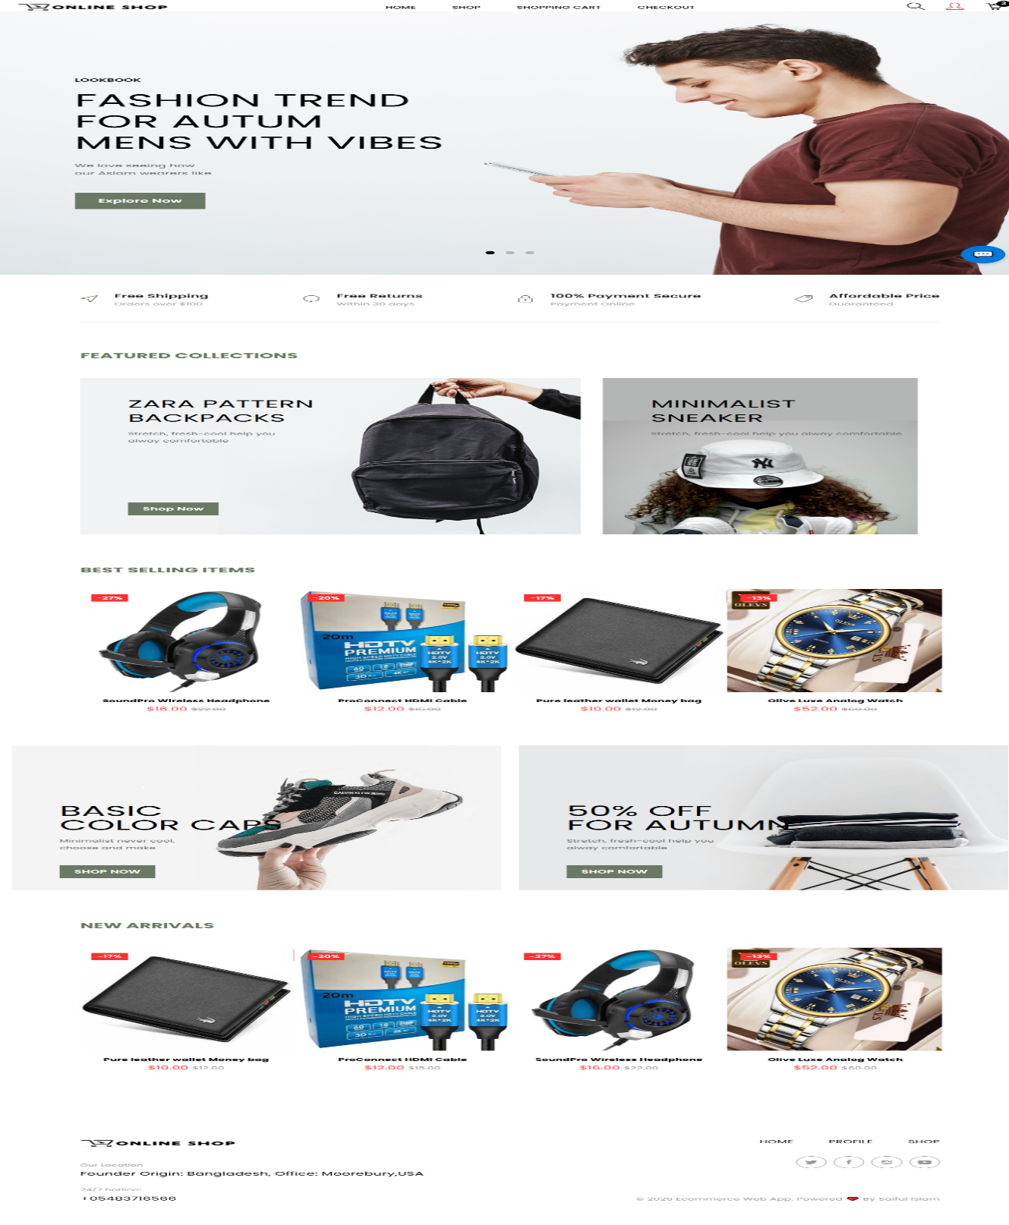

Fig 3.1: Home Page of the Online Shopping System

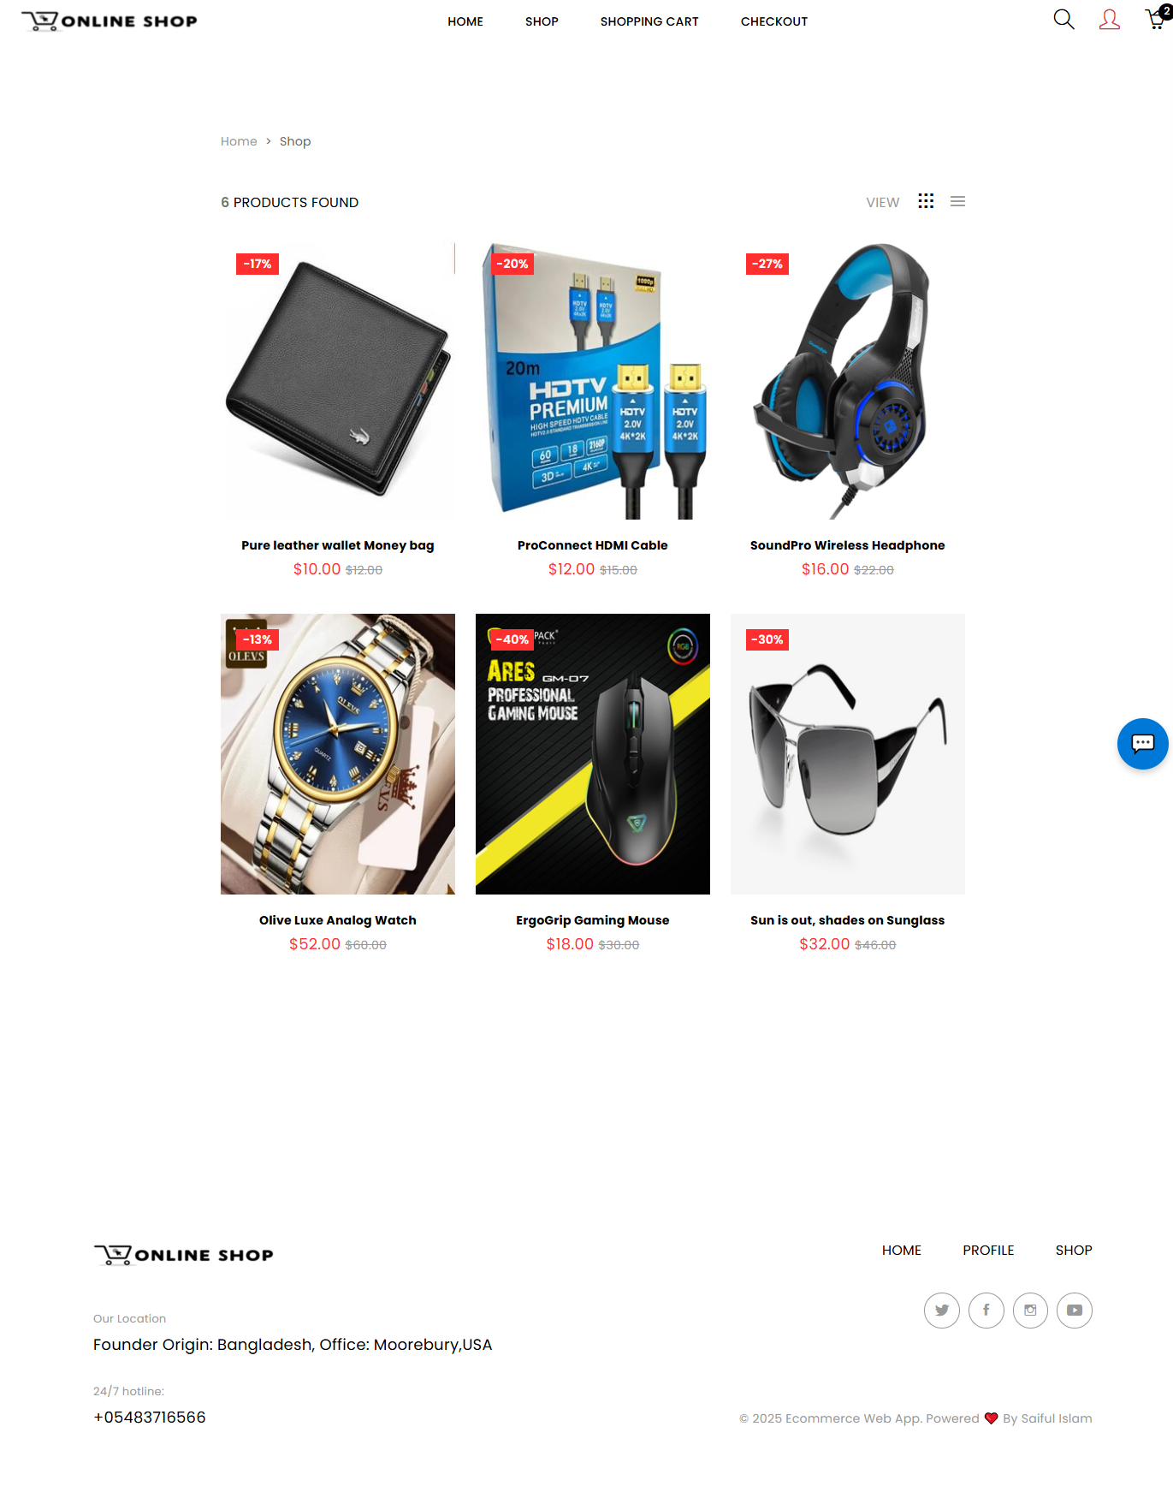

Fig 3.2: User Interface of an E-Commerce Product Grid with Discount Labels

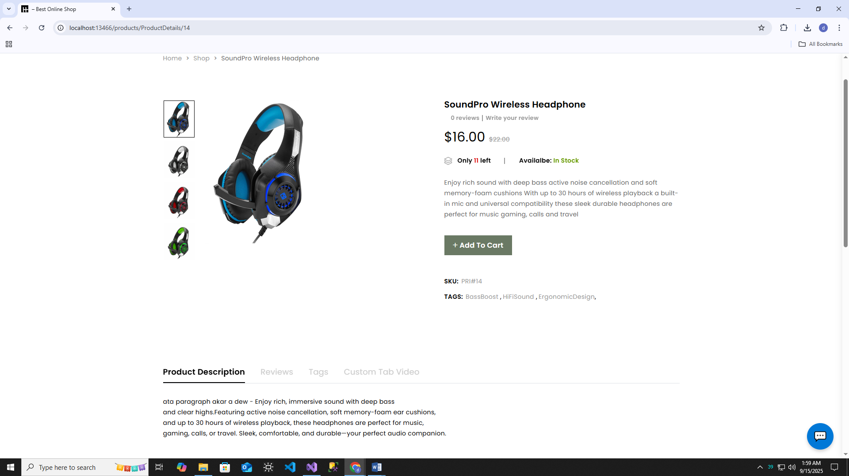

Fig 3.3: Product Details Page Displaying Item Information

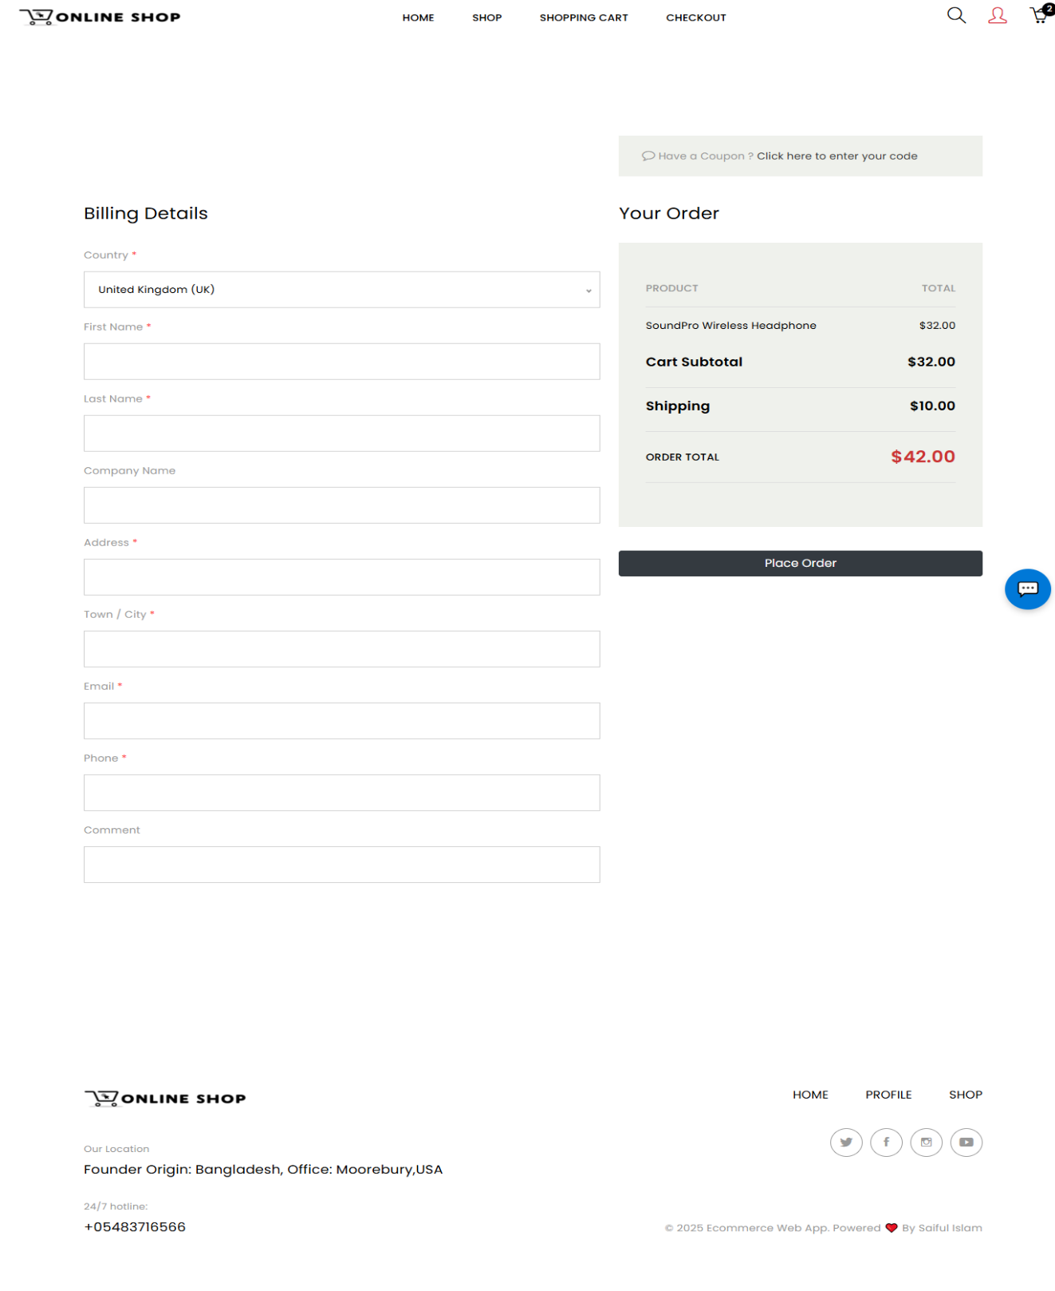

Fig 3.4: E-Commerce Checkout Page with Billing and Order Details

### **3.1.2 Non‑Functional Requirements**

Non‑functional requirements define the quality attributes of the system, focusing on performance, security, usability, and reliability.

1. **Performance**
   * The system must handle at least **100 concurrent users** without performance degradation.
   * Page load times should be under **3 seconds** for standard broadband connections.
2. **Security**
   * All sensitive data, including passwords, must be stored using secure hashing (e.g., PBKDF2, bcrypt).
   * The system must use HTTPS to encrypt data in transit.
   * User sessions must expire after a period of inactivity.
3. **Usability**
   * The interface must be responsive and mobile‑friendly, achieved through **Bootstrap** integration.
   * Navigation should be intuitive, with clear labels and consistent design.
4. **Reliability**
   * All order and product data must be stored in a relational database with ACID compliance.
   * Regular backups must be scheduled to prevent data loss.

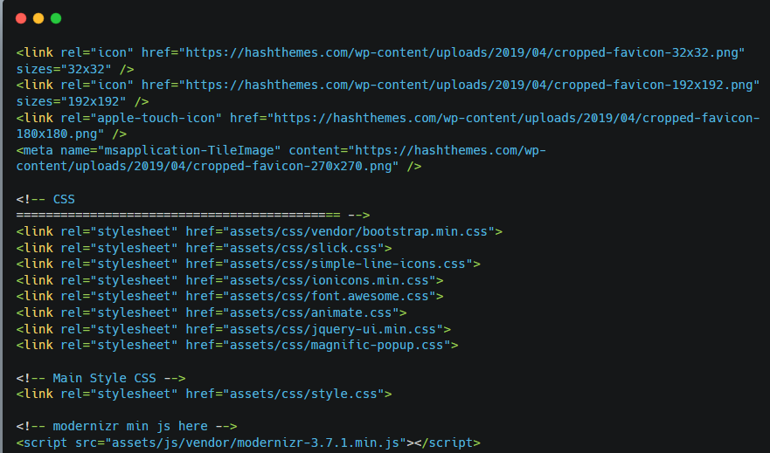

Fig 3.5: Bootstrap integration in _Layout.cshtml for Responsive UI

### **3.1.3 User Requirement Specification**

To develop a successful Online Shopping System, it is essential to clearly define the requirements of different types of users. In this system, there are mainly two categories of users — **Customer** and **Admin**.

* **Customer** is the primary end-user who visits the website to browse products, add items to the cart, and place orders.
* **Admin** is the system manager responsible for managing products, updating or deleting items, and monitoring customer activities such as orders and user details.

The following table presents the specific requirements of each user category in a clear and structured manner.

|  |  |
| --- | --- |
| **User Type** | **Requirements** |
| Customer | Login/Signup, Browse products, Add to cart, Place order |
| Admin | Manage products, View orders, Manage users |

Table 3.1: Use Case Descriptions

**3.2 Use Case Analysis**

Use case analysis provides a structured approach to understanding how various user roles engage with the system to accomplish specific tasks. It identifies the interactions between users (actors) and system functionalities, highlighting the flow of activities, input/output requirements, and expected outcomes. This analysis helps in defining system boundaries, validating functional requirements, and ensuring that the design aligns with real-world usage scenarios. By mapping out these interactions, developers and stakeholders can better anticipate user needs, optimize system behavior, and enhance overall usability.

### **3.2.1 Use Case Diagram**

**Actors:**

* **Customer**
* **Admin**

**Use Cases:**

1. Login
2. Browse Products
3. Add to Cart
4. Checkout
5. Manage Products

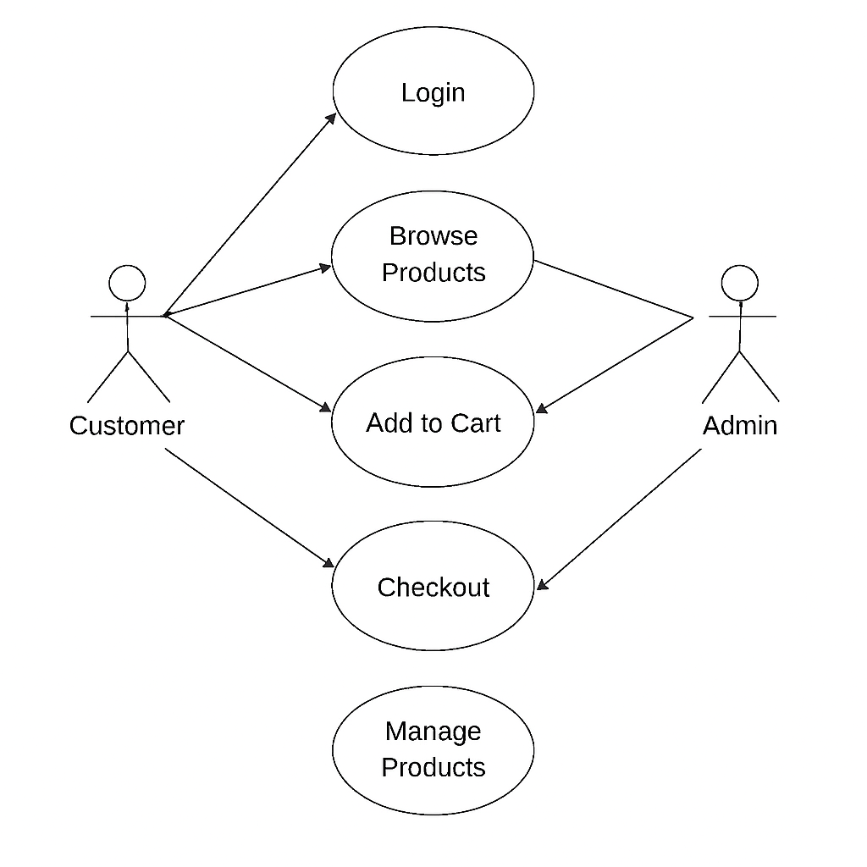

Fig 3.6: Customer and Admin Use Cases in E‑Commerce

**3.2.2 Use case descriptions**

This table explains each use case in detail — who performs it and what it does.

Here’s the table you should include:

Table 3.2: Functional Use Cases of the System

| **Use Case ID** | **Use Case Name** | **Actor** | **Description** |
| --- | --- | --- | --- |
| UC-01 | Login | Customer/Admin | User logs into the system |
| UC-02 | Browse | Customer | Customer views available products |
| UC-03 | Add to Cart | Customer | Customer adds products to shopping cart |
| UC-04 | Checkout | Customer | Customer places an order |
| UC-05 | Manage Prod | Admin | Admin adds, updates or deletes products |

**3.3 Data Flow Diagrams (DFD)**

The Data Flow Diagram (DFD) illustrates how information moves through the **Online Shopping System**. It provides a step‑by‑step view of processes, data stores and external entities.

**3.3.1 Level 0:**

Shows the system as a single process with inputs from **Customer** , **Admin** and outputs such as **Product Information** and **Order Confirmation.**

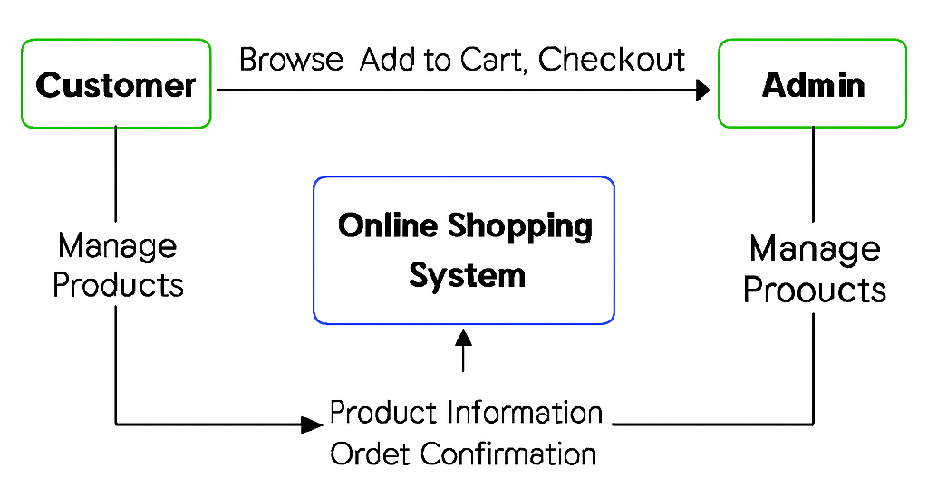

Fig 3.7: Online Shopping System Flowchart

**3.3.2 Level 1:**

Breaks the system into major processes — **Login**, **Browse Products**, **Add to Cart** and **Checkout**. It highlights how customers interact with the system and how data flows to/from the database.

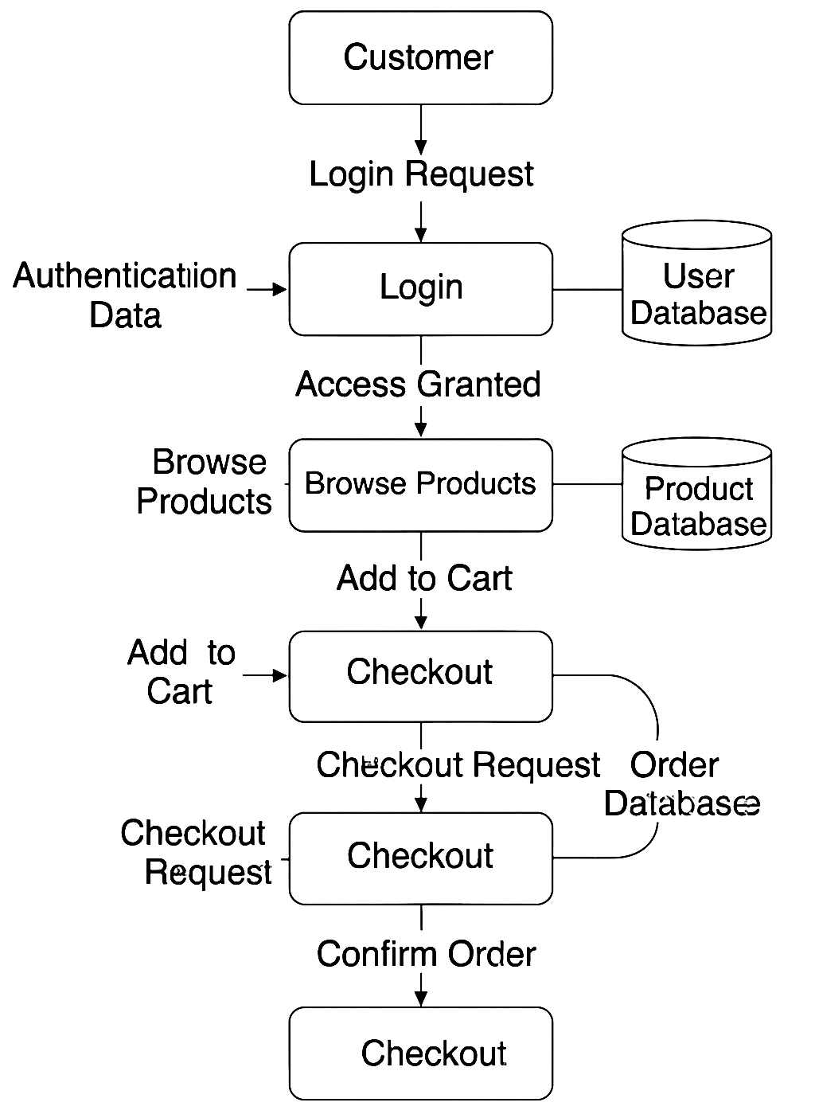

Fig 3.8: End-to-End Online Shopping Process Flow

**3.3.3 Level 2:**

Focuses on the **Checkout process**, showing sub‑processes like **Payment Processing** and **Order Confirmation**, along with interactions with the **Payment Gateway** and **Order Database.**

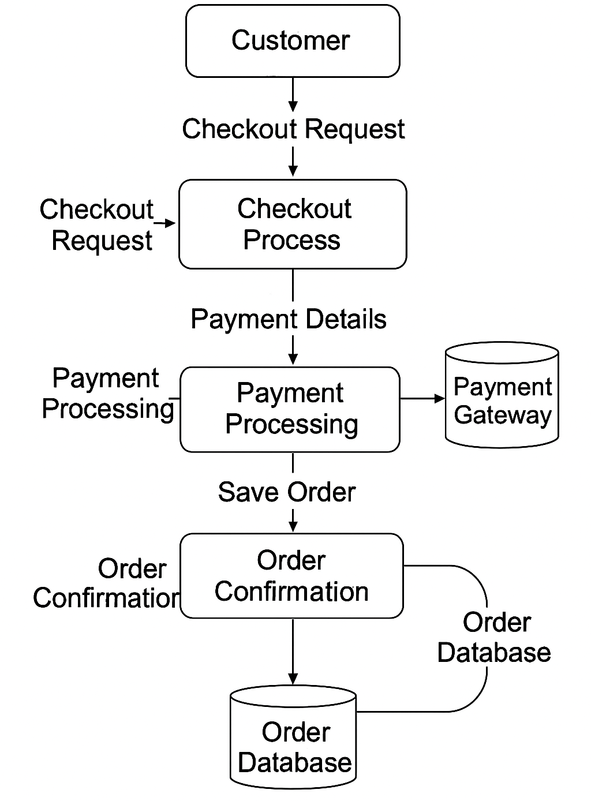

Fig 3.8: Data Flow Diagram of Online Checkout Process

**3.4 Entity Relationship Diagram (ERD)**

The database design includes the following entities and relationships:

• **User**

• **Product**

• **Order**

• **OrderDetails**

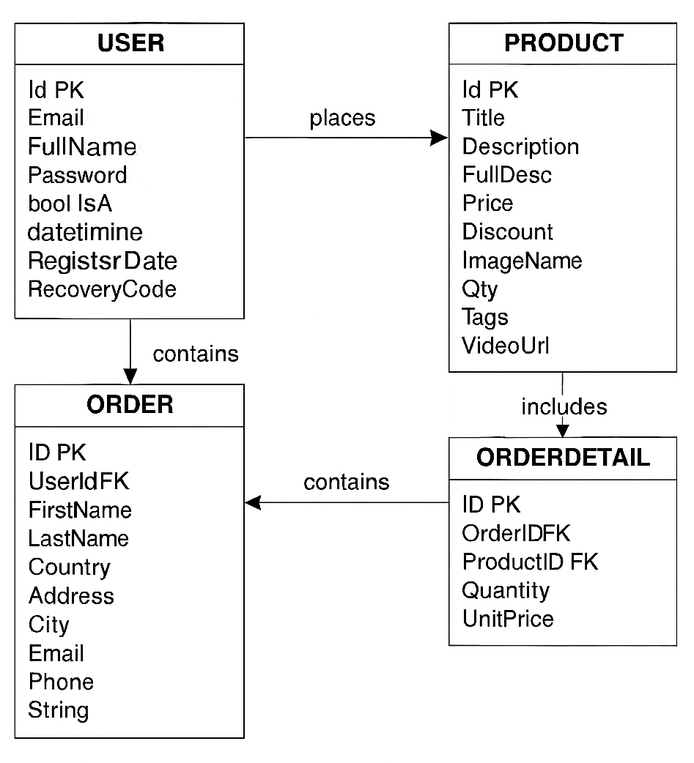

Fig 3.8: ERD of User, Order, Product, and OrderDetail

**3.5 Class Diagram**

The UML Class Diagram illustrates the **core models of the Online Shop system**, designed using ASP.NET Core MVC. It highlights how **Users, Products and Orders** interact, while also showing the role of additional supporting entities such as **Coupons, Comments, Banners and Configurations**. This diagram provides a clear overview of both the main e-commerce workflow and the auxiliary models that support system functionality.

**2. Relationships:**

* **User → Order (One-to-Many):** A single user can place multiple orders.
* **Order → OrderDetail (One-to-Many):** Each order can contain multiple order details.
* **Product → OrderDetail (One-to-Many):** A single product can be included in multiple order details.
* **Product → ProductGallery (One-to-Many):** Each product can have multiple images in its gallery.
* **Other Entities (Banner, Coupon, Setting):** These are independent standalone entities used for configuration and management.

Now The following table provides a brief overview of each class in the online shop system, summarizing their purpose and the key information they store. This complements the relationships described above and helps understand the role of each entity in the system.

Table 3.3: Core Classes and Their Roles

| **Class Name** | **Description** |
| --- | --- |
| **User** | Stores customer/admin information including email, password, role and registration details. |
| **Product** | Holds product data such as title, description, price, discount, stock and media. |
| **Order** | Represents a customer purchase including customer info, total, status and date. |
| **OrderDetail** | Junction entity mapping products to orders with quantity and price. |
| **Comment** | User-generated comments and reviews on products. |
| **Coupon** | Discount codes applied to orders. |
| **ProductGallery** | Stores multiple images for a product. |
| **Banner** | Homepage or promotional banners. |
| **MenusDb** | Navigation menu configuration. |
| **Setting** | Global website settings. |
| **PaypalConfiguration** | Stores PayPal integration details for payment. |
| **ErrorViewModel** | Used in MVC views to display error details. |

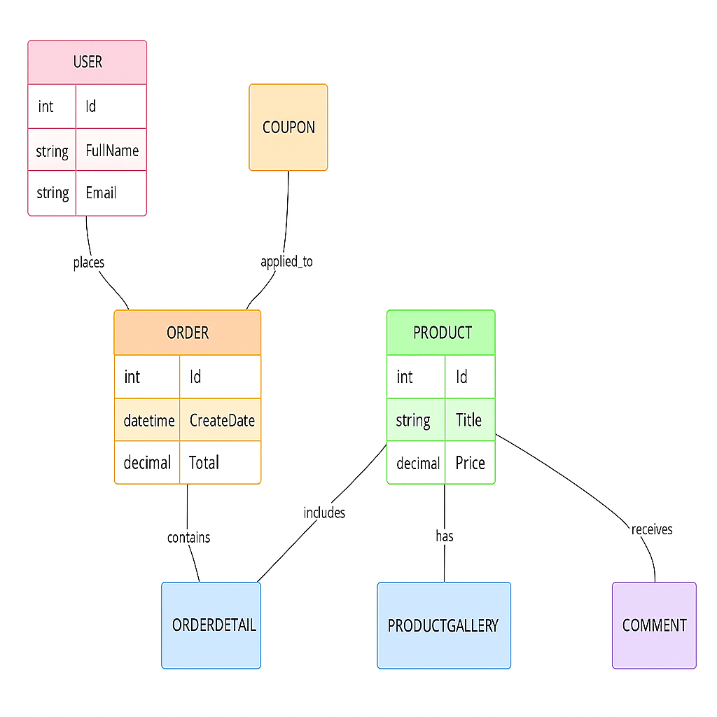The Class Diagram of the system is shown below:

Fig 3.9: Class Diagram of the Online Shopping System

This chapter presents the detailed design and analysis of the proposed Online Shopping System. It describes the overall system architecture, data flow and database structure. The Data Flow Diagrams (DFD) illustrate how information moves through different processes such as product browsing, adding items to the cart, and order checkout. The Entity Relationship Diagram (ERD) defines the main entities and their relationships ensuring an efficient and normalized database design. Additionally the Class Diagram represents the object-oriented structure of the system using C# models. Overall, this chapter establishes a clear blueprint for the implementation of the system in the subsequent stages.

**CHAPTER 4**

**SOFTWARE PROCESS**

**4.1 Software Process Model**

Software processes, methodologies, and frameworks range from specific prescriptive steps that organizations can apply in daily operations to flexible frameworks tailored to a project or team. Sponsoring organizations often provide detailed documentation describing the process. In online business systems, software streamlines various steps involved in purchasing. “Software” refers to programs, procedures, and documentation, such as manuals and flowcharts, describing the program and its usage. A software process is a set of activities and outcomes that produce a software product, primarily performed by software engineers. The four key process activities are software specification, defining functionality and constraints; software development, producing the software to meet requirements; software validation, ensuring it works as intended and software evolution, adapting and enhancing it to meet changing needs.

**Software Process and Software Development Lifecycle Model**

he concept of the Software Development Life Cycle (SDLC) models represents a fundamental aspect of software development processes. Various development life cycle models have been created to achieve different objectives. These models define the distinct stages of the process and the sequence in which they are executed. The most widely used and important models are discussed below.

Software Development Life Cycle (SDLC) Models:

* Waterfall model
* V model
* Incremental model
* RAD model
* Agile model
* Iterative model
* Spiral model
* Prototype model

**4.2 Waterfall Model**

The Waterfall model is a highly structured approach to software and system development that divides project activities into distinct, linear, and sequential phases. In this model, each phase depends on the deliverables and outcomes of the preceding phase, ensuring a clear and organized progression from start to finish. Every phase corresponds to a specific set of specialized tasks, such as requirements gathering, system design, implementation, testing, and maintenance. This approach is particularly suitable for projects in engineering, system design, and other domains where requirements are well-understood and changes during development are minimal, providing a predictable and disciplined framework for project execution.

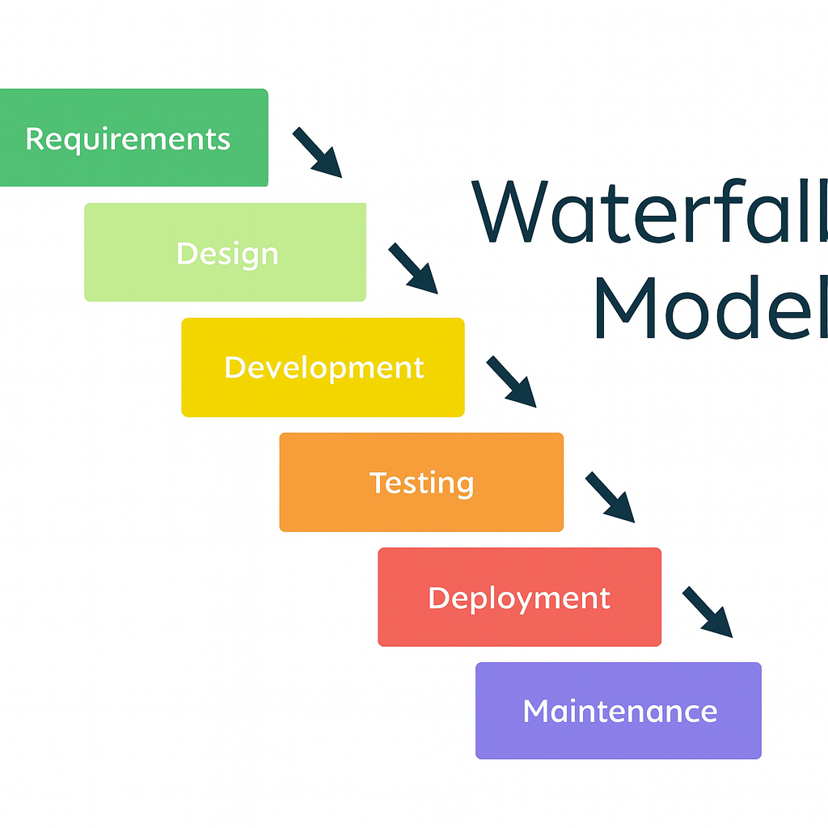

Fig 4.2: Waterfall Model

**4.3 V Model**

The V-model represents a development process that can be viewed as an advanced extension of the traditional Waterfall model and serves as an example of the broader V-model concept. Rather than progressing strictly in a downward linear sequence like the Waterfall model, the V-model bends upward after the coding phase, forming a distinct “V” shape. This upward movement visually illustrates how each stage of development is directly linked to a corresponding phase of testing. The model emphasizes the importance of verification and validation at every step of the software life cycle, ensuring that each deliverable is carefully reviewed and tested. The V-model clearly demonstrates the relationship between development activities on the left side and testing activities on the right side. The horizontal axis represents the project timeline or level of completion from left to right, while the vertical axis represents the level of abstraction, with the highest and most general concepts at the top and the most detailed implementations toward the bottom. Overall, the V-model provides a clear, structured, and disciplined approach to software development that enhances quality assurance and reduces the likelihood of errors.

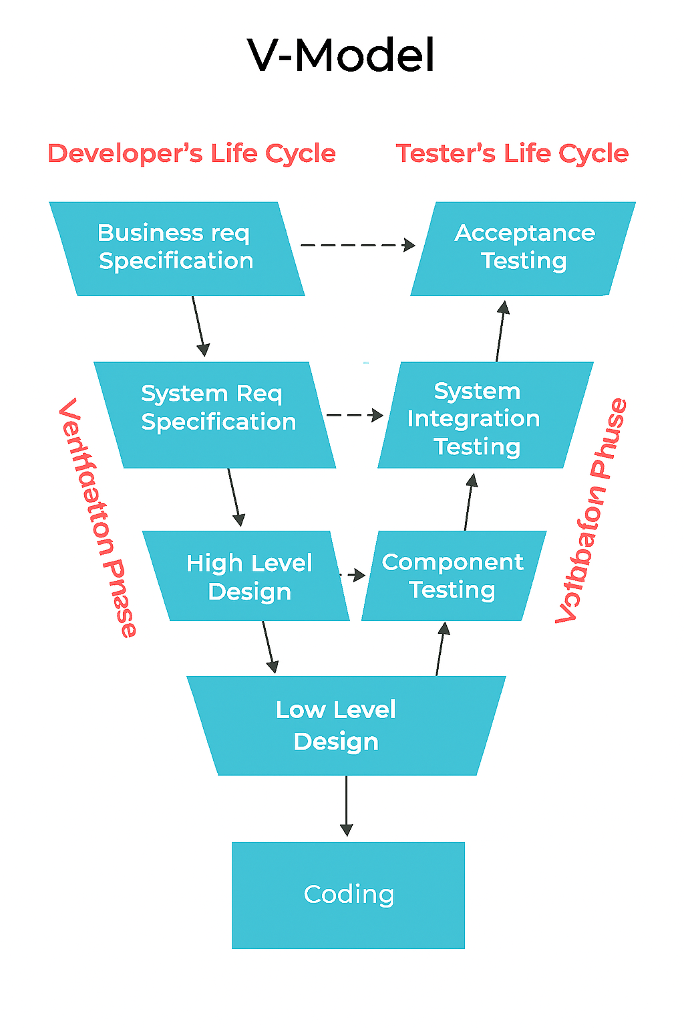

Fig 4.3: V Model

**4.4 Incremental Model**

**The incremental build model** is a method of software development where the model is designed, implemented, and tested incrementally (a little more is added each time) until the product is finished. It involves both development and maintenance. The product is defined as finished when it satisfies all of its requirements. Each iteration passes through the requirements, design, coding, and testing phases. And each subsequent release of the system adds function to the previous release until all designed functionality has been implemented. This model combines the elements of the waterfall model with the iterative philosophy of prototyping.

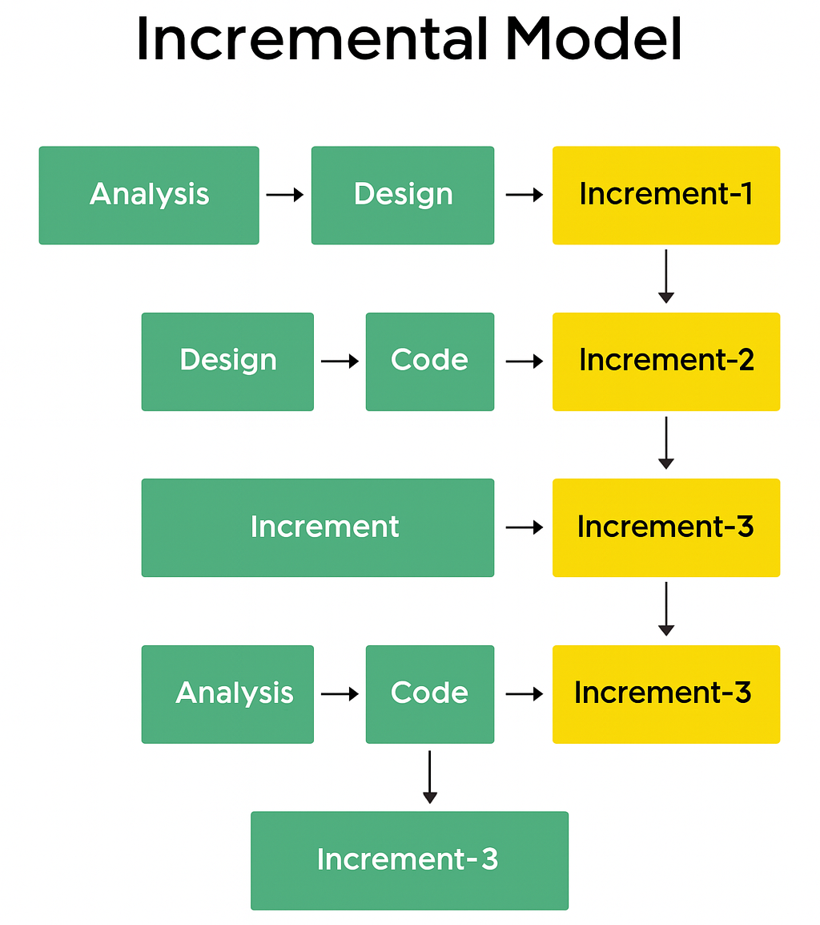

Fig 4.4: Incremental Model

**4.5 Iterative Model**

An iterative life cycle model does not attempt to start with a full specification of requirements but instead focuses on an initial, simplified set of user features which then progressively gain more complexity and a broader set of functionalities until the targeted system is complete. When adopting the iterative approach, the philosophy of incremental development is often used interchangeably as both emphasize gradual improvement through repeated cycles. In this approach development begins by specifying and implementing only a part of the software, which is then reviewed and prioritized to identify additional requirements. The process is repeated in multiple iterations, with each iteration delivering a new and improved version of the software. In lightweight iterative projects the code itself may serve as the primary source of system documentation; however in more critical iterative projects a formal software specification may also be required.

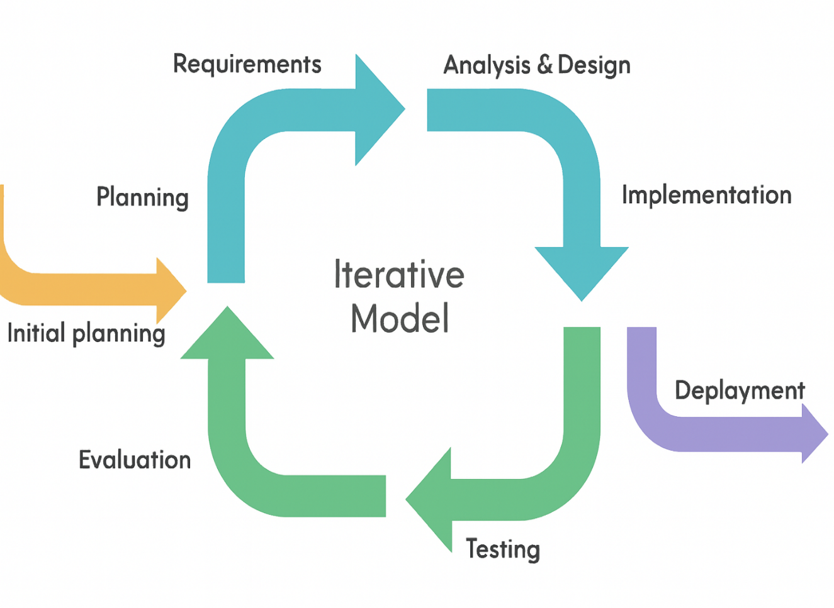

Fig 4.5: Iterative Model

**4.5 Rad Model**

**Rapid Application Development (RAD)** was introduced as a response to plan-driven waterfall processes developed in the 1970s and 1980s, such as the **Structured Systems Analysis and Design Method (SSADM)**. Rapid Application Development is often referred to as **adaptive software development**. RAD is an incremental prototyping approach to software development that allows end users to provide better feedback by examining a live system, rather than working strictly from documentation. It places less emphasis on planning and more emphasis on an adaptive process. RAD may result in a lower level of rejection when the application is deployed into production; however, this success often comes at the expense of dramatic overruns in project cost and schedule. The RAD approach is especially well-suited for developing software driven by user interface requirements. Thus, some GUI builders are often referred to as **Rapid Application Development tools.**

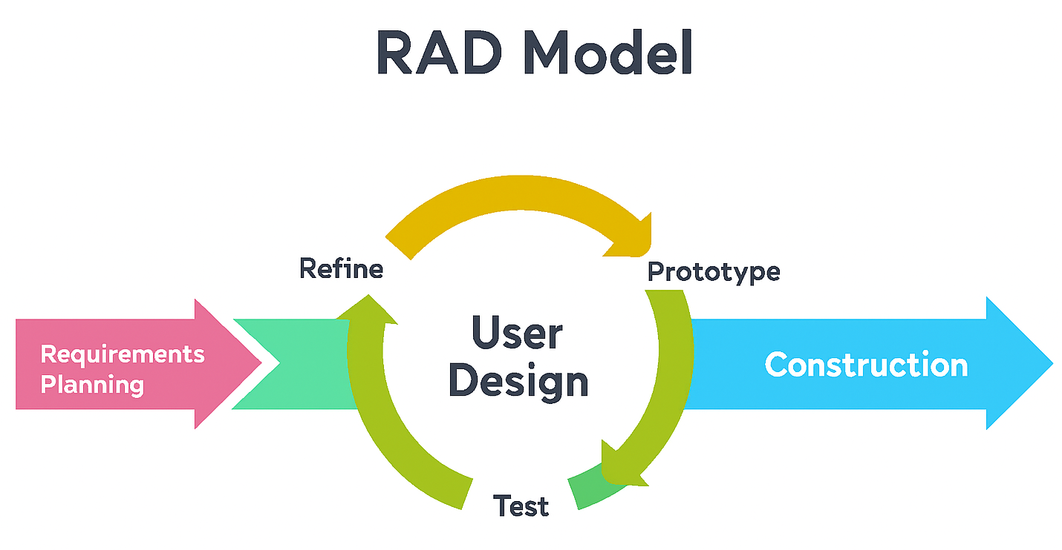

Fig 4.6: Rapid Application Development(RAD)

**4.6 Spiral Model**

The Spiral Model, first described by Barry Boehm in 1986, is a risk-driven software development process model introduced to overcome the shortcomings of the traditional Waterfall Model. A spiral model looks like a spiral with multiple loops. The exact number of loops is not fixed and can vary from project to project. This model supports effective risk handling, and the project is delivered in iterative loops. Each loop of the spiral is referred to as a phase of the software development process. The initial phase of the Spiral Model begins with the early stages of the Waterfall Life Cycle required to develop a software product. The number of phases needed to complete the product can vary depending on the project risks, as determined by the project manager. Since the project manager dynamically defines these phases, they play a crucial role in successfully developing a product using the Spiral Model.

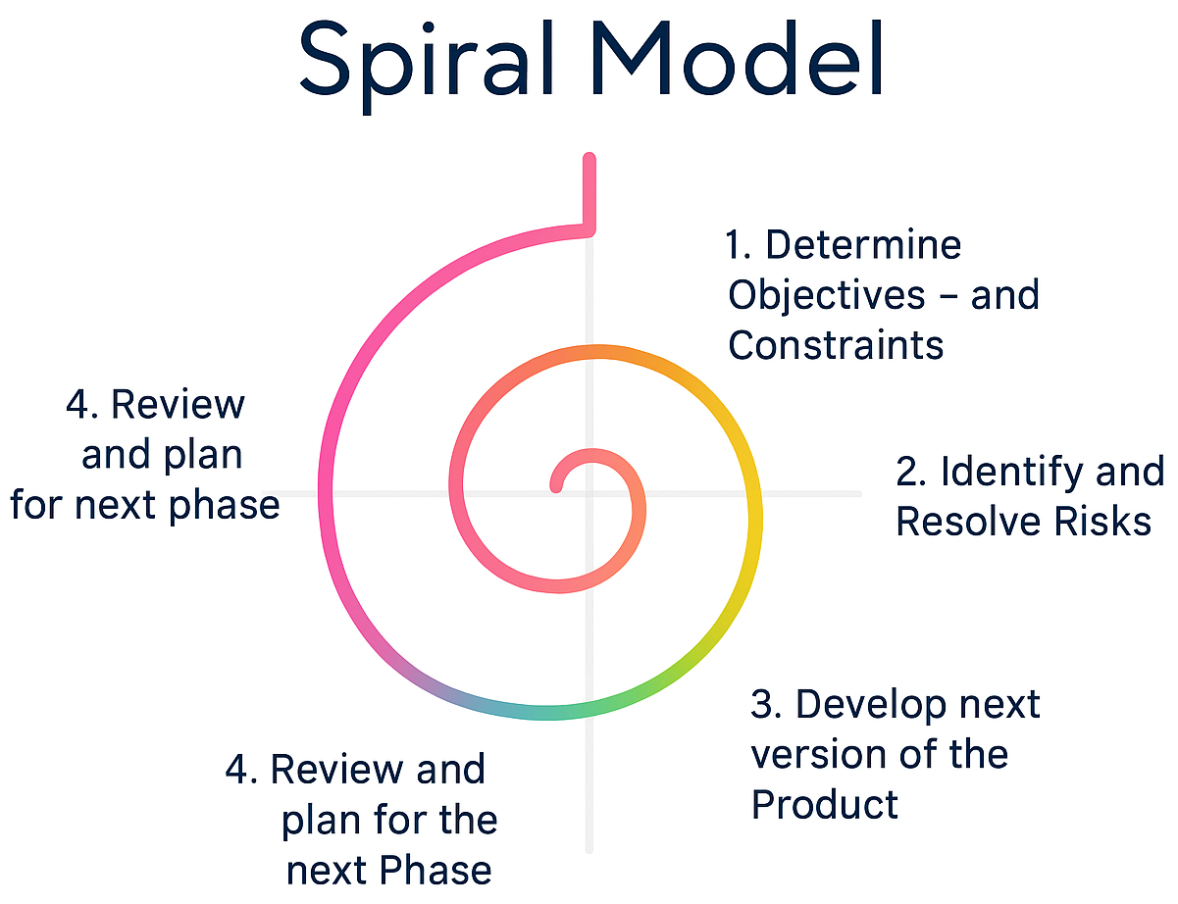

Fig 4.7: Spiral Model

**4.7 Agile Model**

**Agile** is an umbrella term for a set of methods and practices based on the values and principles expressed in the Agile Manifesto. It represents a way of thinking that enables teams and businesses to innovate, quickly respond to changing demands and mitigate risks. Organizations can adopt agility using various available frameworks such as Scrum, Kanban, Lean, and Extreme Programming (XP) among others.

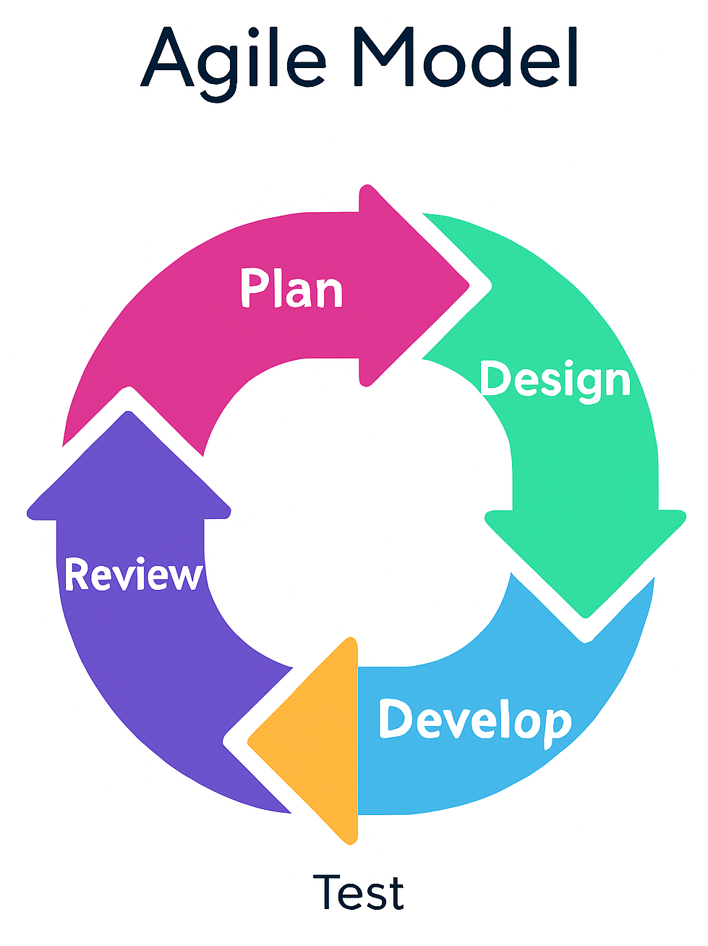

Fig 4.8: Agile Model

The Agile movement proposes alternatives to traditional project management. Agile approaches are typically used in software development to help businesses respond to unpredictability which refer to a group of software development methodologies based on iterative development, where requirements and solutions evolve through collaboration between self-organizing cross-functional teams. The primary goal of being Agile is empowered the development team the ability to create and respond to change in order to succeed in an uncertain and turbulent environment. Agile software development approach is typically operated in rapid and small cycles. This results in more frequent incremental releases with each release building on previous functionality. Thorough testing is done to ensure that software quality is maintained.

**CHAPTER 5**

**SYSTEM ANALYSIS AND ARCHITECTURE**

**5.1 System Architecture**

**The proposed Online Shopping System follows a three-tier client-server architecture that separates the system into different manageable layers to ensure scalability, security, and performance. The major components of the system are the User Interface (Client) Application/Server Layer, and Database Layer. Each layer has a specific role in processing user requests and delivering accurate responses. When a user interacts with the system through a web browser, a request is sent to the Web Server. The server processes the request by applying business logic and communicates with the Database Server to store, retrieve, or update data. After processing the request, the server sends the response back to the client, and the result is displayed on the user interface. This continuous data flow ensures smooth and real-time communication between all components. This architecture improves maintainability by separating responsibilities into individual layers. It also enhances security by preventing direct access to the database from the client side.**

**Major Components**

* **Client (Front-End Interface): Accepts user inputs and displays results.**
* **Application Server (Business Logic Layer): Handles order processing, product management, authentication, etc.**
* **Database Server (Data Storage Layer): Stores user, product, order, and payment information securely.**

**Data Flow Process**

1. **User Request: The user sends a request (e.g., browse products, add to cart, login).**
2. **Application Server Processing: The request reaches the application server, where business logic is applied.**
3. **Database Interaction: The server retrieves or updates data from the database.**
4. **Database Response: The database sends the response back to the server.**
5. **Client Response: The server responds to the client with the processed result, which is displayed on the user interface.**

**The following diagram illustrates the overall System Architecture of the proposed Online Shopping System. It shows how the client browser communicates with the web/application server, which in turn interacts with the database server. This layered structure highlights the separation of responsibilities: the client handles user interaction, the server manages business logic, and the database ensures secure storage and retrieval of information. The arrows represent the continuous flow of requests and responses, ensuring smooth communication between all components.**

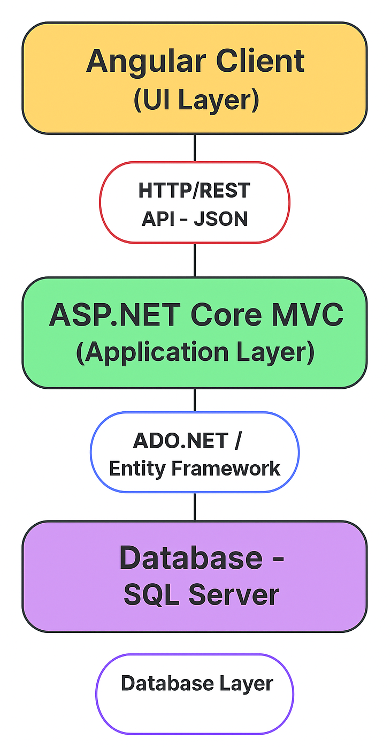

Fig 5.1: Three-Tier Architecture System

**5.2 Client-Server Model**  
**5.3 Database Layer**  
**5.4 Application Layer**  
**5.5 UI Layer**

**5.6 Database Design**  
**5.7 Table and Relationship**  
**5.8 Normalization Process**  
**5.9 SQL Schema**

**5.10 User Interface Design**  
**5.11 Wireframes**  
**5.12 Navigation Flow**

**5.13 Security Design**  
**5.14 Authentication**  
**5.15 Authorization**  
**5.16 Data Protection**